**Assignment 1**

Problem Description:

Write a program that calculates the energy needed

to heat water from an initial temperature to a final temperature. Your program

should prompt the user to enter the amount of water in kilograms and the initial

and final temperatures of the water. If water weight is negative number, the following message should be displayed: *“Water amount cannot be negative number!”*

The formula to compute the energy is:

result = waterWeight * (finalTemperature – initialTemperature) * 4184

**Analysis:**

(Describe the problem including input and output in your own words.)

* 1.In this programme we have to calculate energy required to heat water form initial temperature to final temperature.
* 2.For this we have to get values for water weight, initial temperature and final temperature that are inputs from user.
* 3.The water weight can not be negative. For this condition we have to get output as ***“Water amount cannot be negative number!”***
* 4.For calculation of the energy required we have to get inputs from user for waterWeight, initial temperature and final temperature and use these inputs in the formula.

**Design:**

(Describe the major steps for solving the problem.)

* Prompt user to enter values of the water weight. For that we have to create a scanner object.
* 2.We have to create the 4 variables: waterWeight,initialTemparature,finalTemparature and result
* By taking the value of water weight we have to check whether the value of waterWeight is negative or positive.
* To do so we have to use if and else statement.
* 4. If waterWeight < 0

print “***Water amount cannot be negative number!”***

else

“Enter initial temperature of the water”

“Enter final temperature of the water”

**result = waterWeight * (finalTemperature – initialTemperature) * 4184**

Print “**result**”.

**Coding:**

**package** Assignment;

**import** java.util.Scanner;

**public** **class** EnergyToHeatWater {

**public** **static** **void** main(String[] args) {

// Create scanner object

Scanner sc = **new** Scanner(System.***in***);

// Prompt the user to enter amount of water in kg

System.***out***.print("Enter amount of water in kg:");

**double** waterWeight = sc.nextDouble();

// Putting conditions for water weight

**if** (waterWeight < 0) {

System.***out***.print("Water amount cannot be negative number");

} **else** {

// Prompt the user to enter initial temperature

System.***out***.print("Enter initial temperatures of the water:");

**double** initialTemperature = sc.nextDouble();

// Prompt the user to enter final temperature

System.***out***.print("Enter final temperatures of the water:");

**double** finalTemperature = sc.nextDouble();

// Compute the energy needed to heat water using formula

**double** result = (waterWeight) * (finalTemperature - initialTemperature) * (4184);

// Display Results

System.***out***.print(

"The energy needed to heat water from an initial temperature to a final temperature is:" + result);

}

}

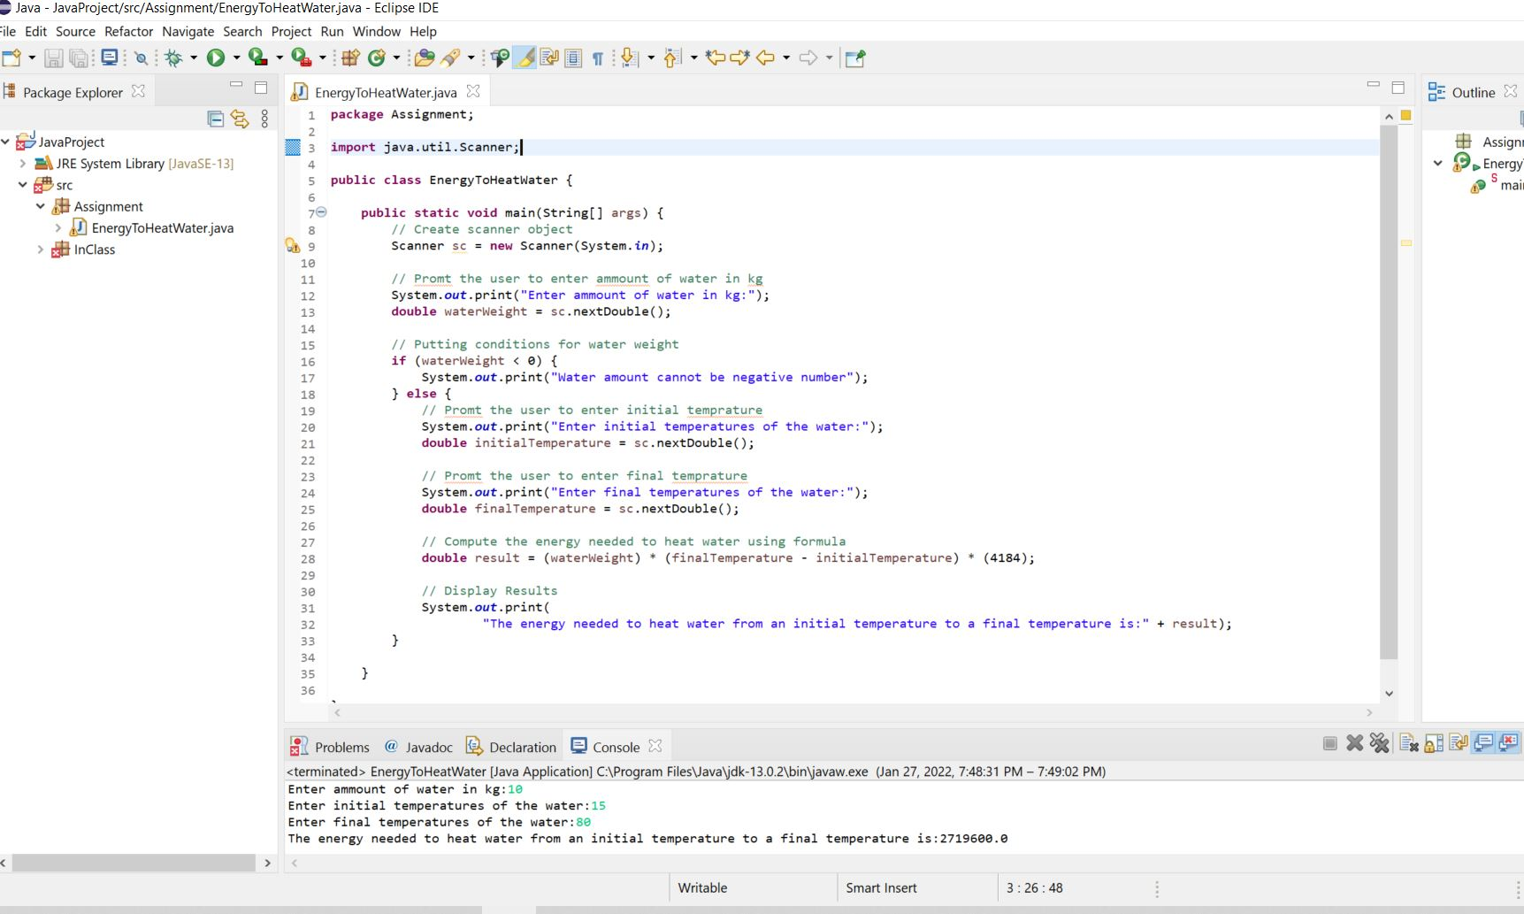

**Testing:**

We can test this programme by 2 test cases.

Test1:

* For test 1 we have to prove the water weight the negative value. So we have given the input as -3.

Result:

* We have got message as “Water amount can not be a negative number.

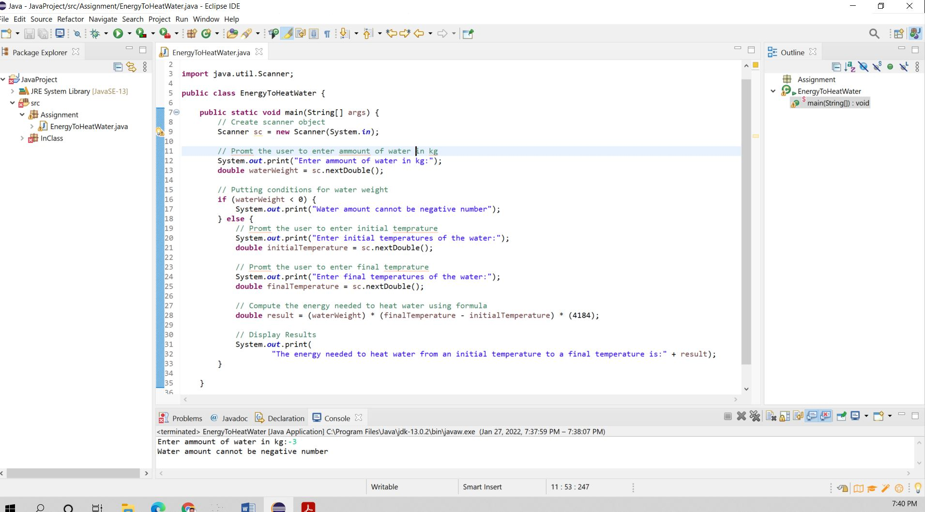

Test2:

For test 2 inputs are:

* Given input for water weight-10
* Initial temperature -15
* Final Temparature-80

Result:

We have got message as “The energy needed to heat from an initial temperature to final temperature is :2719600.00”.

